**Karan Arora** **R.L. Institute M: 9416974837**

**Max Time : 1 hr** **Class : 11th Chemistry Max Marks : 25**

**Redox**

1. Multiple choice Questions: [ 2 x 10 = 20 ]
2. Oxidation state of P in H4P2O5 , H4P2O6 , H4P2O7 are respectively:

|  |  |  |  |
| --- | --- | --- | --- |
| a) + 3 , + 5 , + 4 | b) + 5 , + 3 , + 4 | c) + 5 , + 4 , + 3 | d) + 3 , + 4 , + 5 |

1. The oxidation numbers of the Sulphur atoms in peroxomonosulphuric acid (H2SO5) and peroxodisulphuric acid (H2S2O8) are respectively:

|  |  |  |  |
| --- | --- | --- | --- |
| a) + 8 and + 7 | b) + 3 and + 3 | c) + 6 and + 6 | d) + 4 and + 6 |

1. What is the oxidation state of Co in [Co(H2O)5 Cl]2+ ?

|  |  |  |  |
| --- | --- | --- | --- |
| a) + 2 | b) + 3 | c) + 1 | d) + 4 |

1. Oxidation state of each Cl in CaOCl2 is/are :

|  |  |  |  |
| --- | --- | --- | --- |
| a) 0 | b) + 1 | c) – 1 | d) + 1 , – 1 |

1. The oxidation state of S atoms in S4 from left to right respectively are:

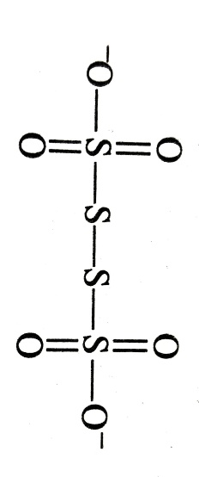

|  |  |  |  |
| --- | --- | --- | --- |
| a) + 6 , 0, 0 , + 6 | b) + 3 , + 1 , + 1 , + 3 | c) + 5 , 0, 0 , + 5 | d) + 4 , + 1 , + 1 , + 4 |

1. When KMnO4 acts as an oxidizing agent and ultimately forms , MnO2 , Mn2O3 and Mn2+, then the number of electrons transferred in each case respectively, is :

|  |  |  |  |
| --- | --- | --- | --- |
| a) 4 , 3 , 1 , 5 | b) 1 , 5 , 3 , 7 | c) 1 , 3 , 4 , 5 | d) 3 , 5 , 7 , 1 |

1. In the redox reaction, x KMnO4 + NH3 y KNO­3 + MnO2 + KOH + H2O.

|  |  |  |  |
| --- | --- | --- | --- |
| a) x = 4 , y = 6 | b) x = 3 , y = 8 | c) x = 8 , y = 6 | d) x = 8 , y = 3 |

1. In the balanced chemical reaction, + a + b H+ c H2O + d

A, b , c and d respectively correspond to :

|  |  |  |  |
| --- | --- | --- | --- |
| a) 5 , 6 , 3 , 3 | b) 5 , 3 , 6 , 3 | c) 3 , 5 , 3 , 6 | d) 5 , 6 , 5 , 5 |

1. Which of the following is a set of reducing agents?

|  |  |  |  |
| --- | --- | --- | --- |
| a) HNO3 , Fe2+ , F2 | b) F –  , Cl –  , | c) , Na , Fe2+ | d) , , Na |

1. Which of the following species can function both as oxidizing as well as reducing agent?

|  |  |  |  |
| --- | --- | --- | --- |
| a) Cl – | b) ${ClO}_{4}^{-}$ | c) ${ClO}^{-}$ | d) ${MnO}_{4}^{-}$ |

1. Using standard electrode potentials, predict the reaction, if any, that occurs between Fe3+(aq) and I– (aq)

$E_{{ Fe}^{3+}/{Fe}^{2+}}^{o}$ = 0.77 V , $E_{I_{2}/{2I}^{-}}^{o}$ = 0.54 V [ 2 ]

1. Two half cells are : Al3+ (aq)/Al and Mg2+ (aq)/Mg. The reduction potentials of these half cells are $-$ 1.66 V and $-$ 2.36 V respectively. Calculate the cell potential. Write the cell reaction also. [ 3 ]